Project Title: Building a Retail Sales Data Agent on Databricks
Student Name: Nonofo Sebako
Course: BrightLearn AI & Data Skills
Due Date: 24 May 2026
Introduction & Objective:
The objective of this project is to build a Retail Sales Data Agent using Databricks and a retail sales dataset. The agent is designed to help business users analyse sales performance, customer behaviour, product trends, and revenue patterns using natural language questions.

The project demonstrates how AI-powered data agents can support decision-making in retail businesses by transforming raw sales data into meaningful business insights.

Step 1: UPLOAD DATASET
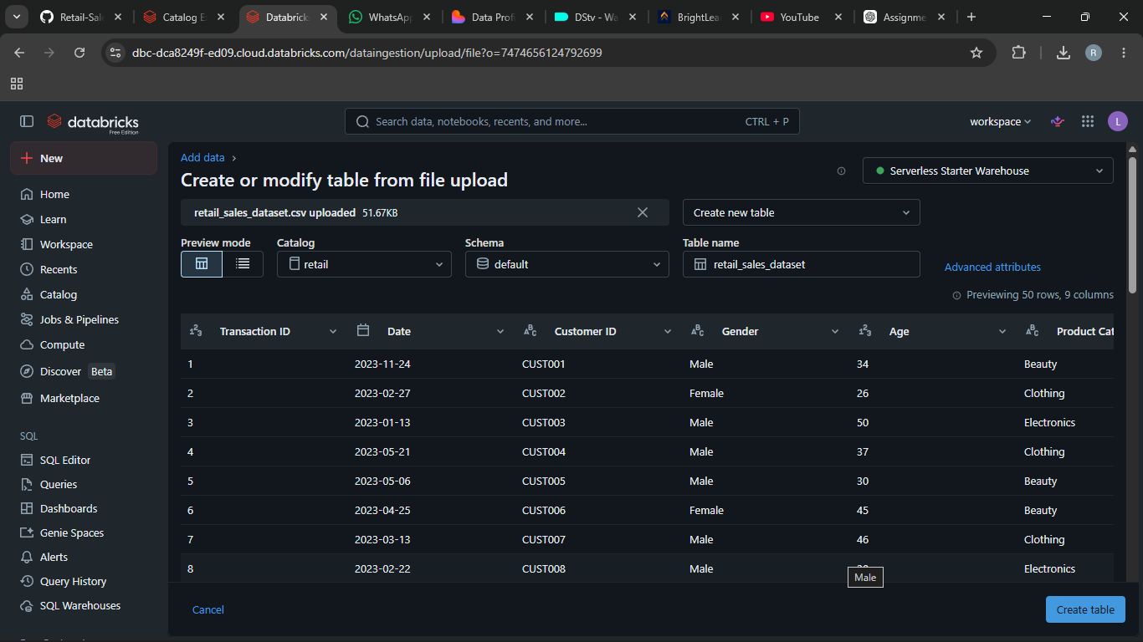

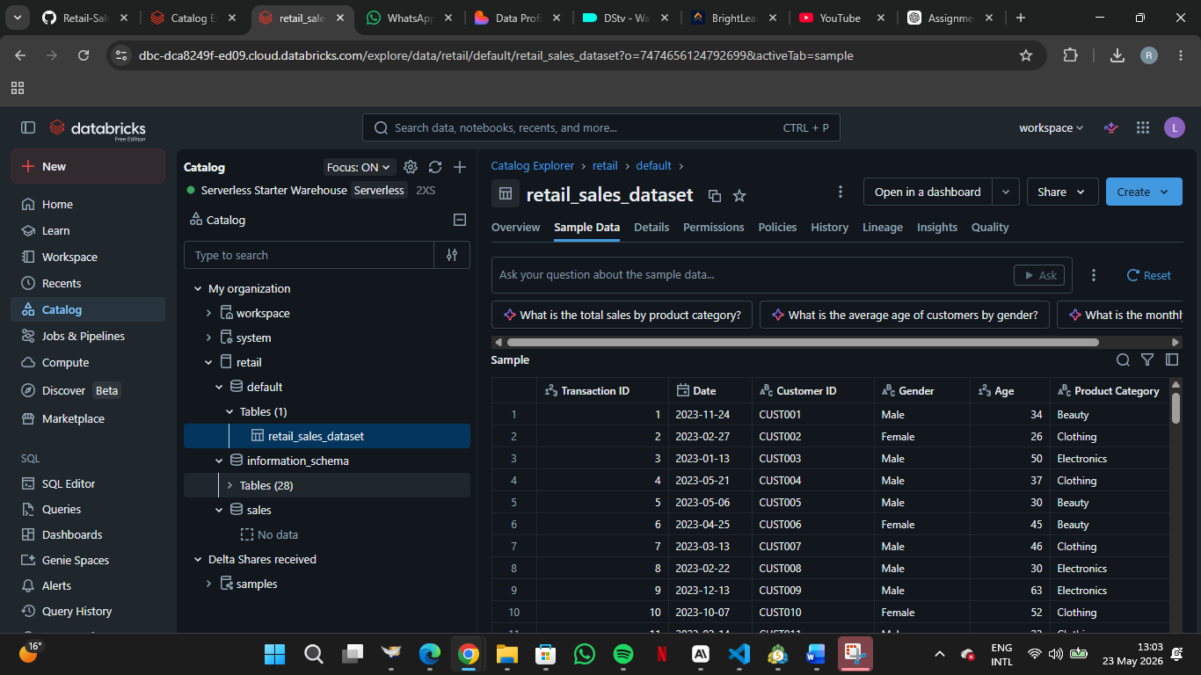

STEP 2: REVIEW COLUMNS
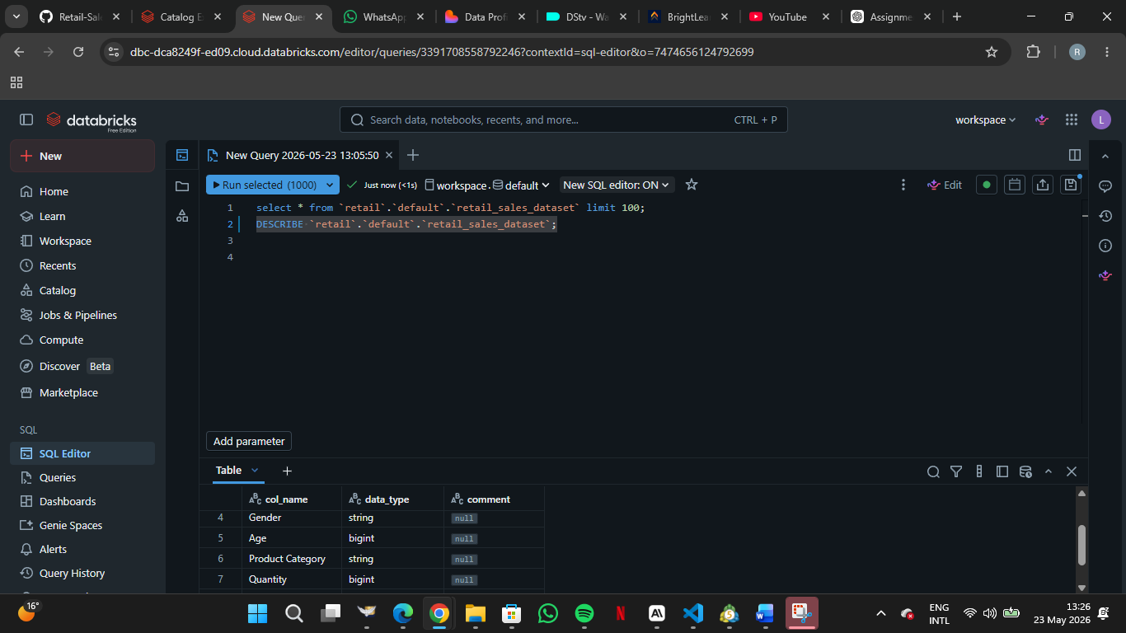

STEP 3: PREPARE THE TABLE
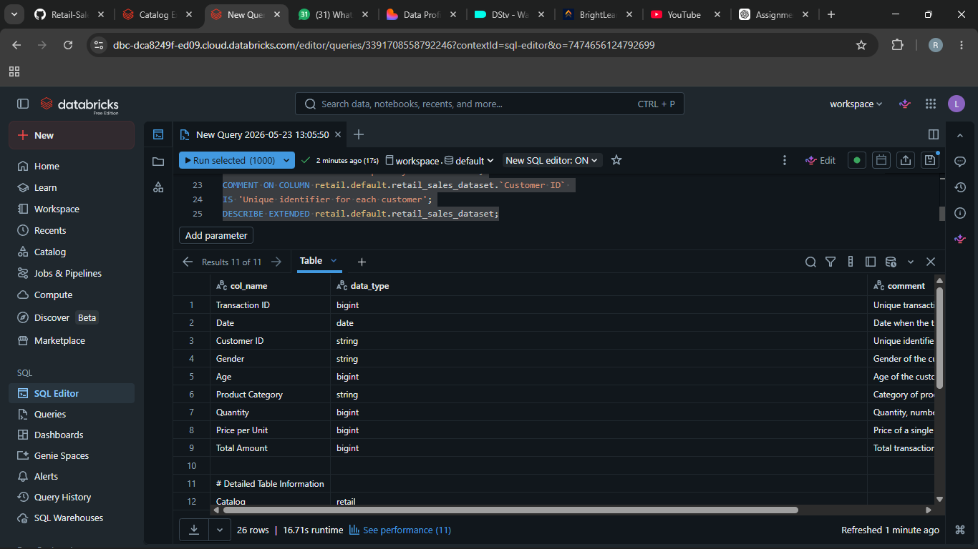
STEP 4: CREATE THE DATA AGENT

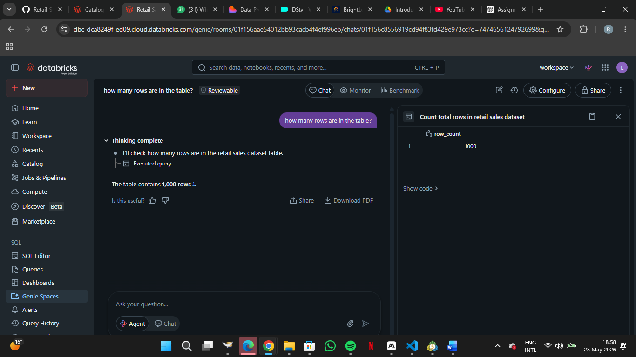

Step 5: Write Your Own Instructions
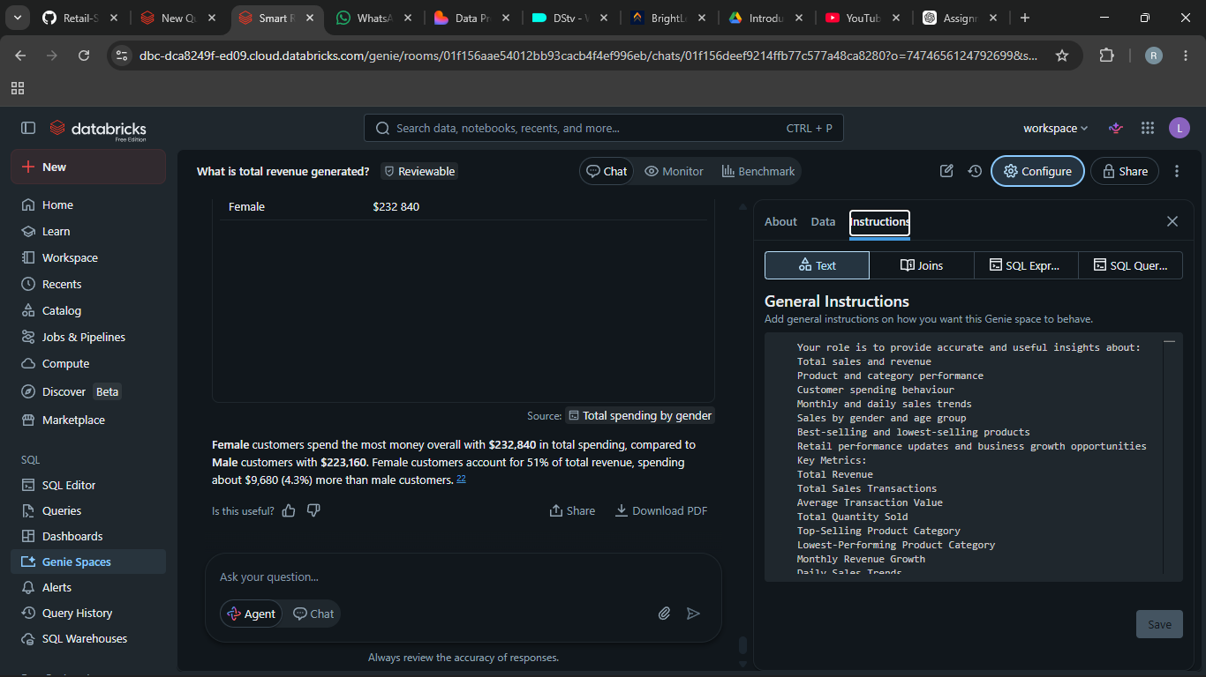

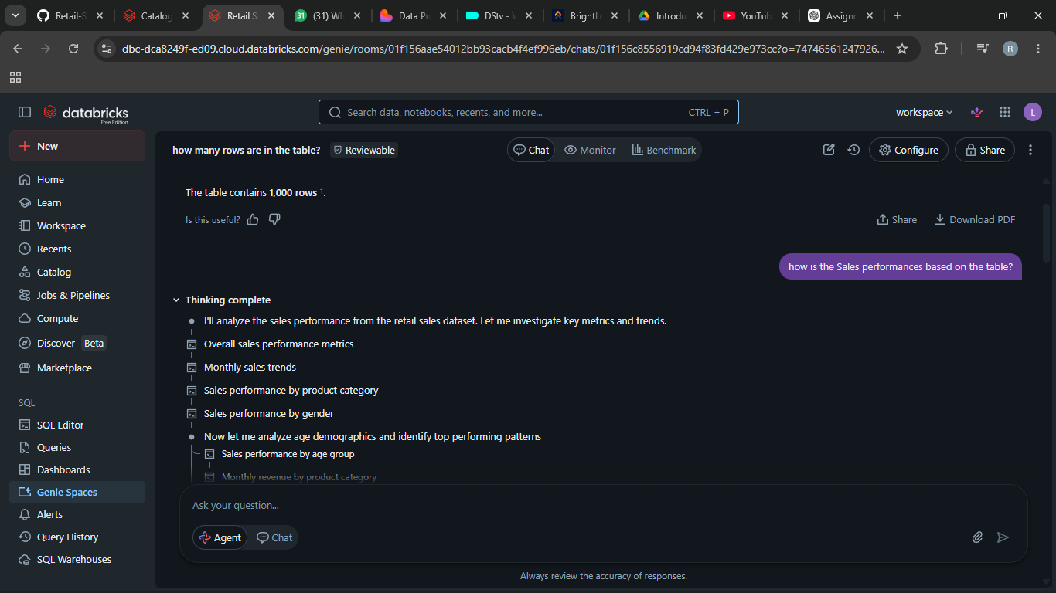
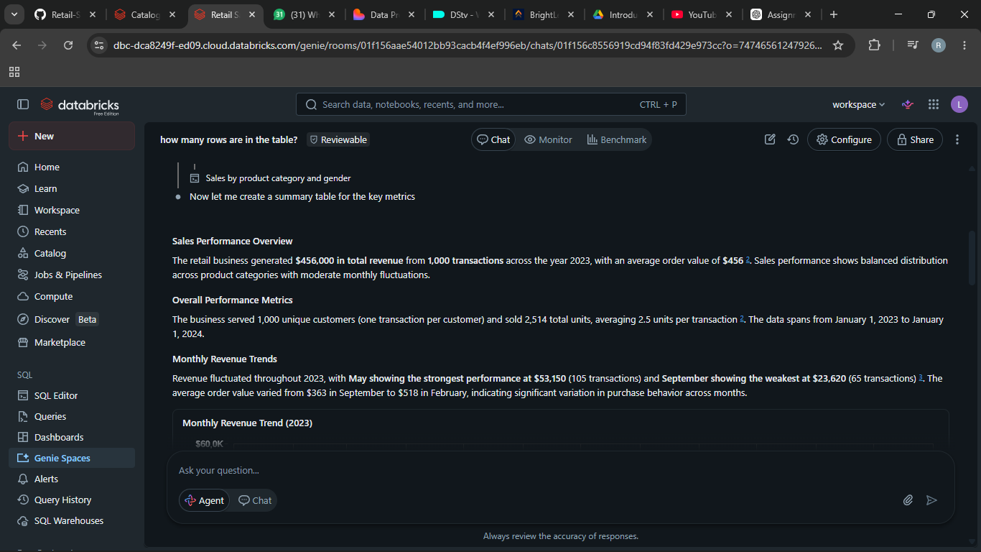

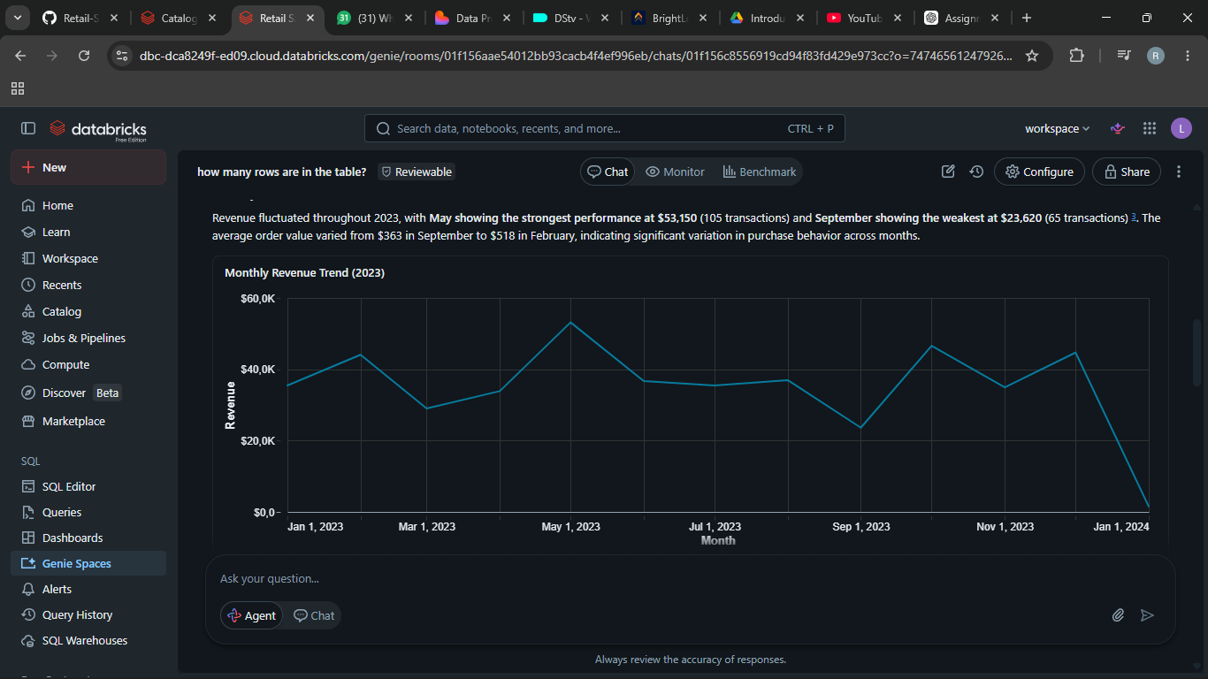
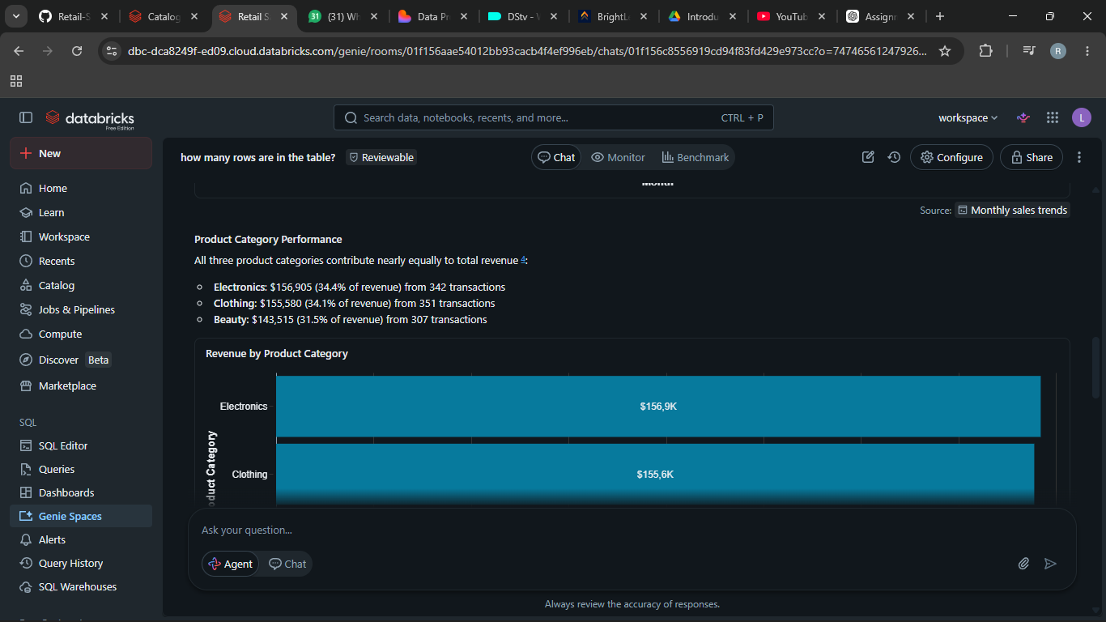
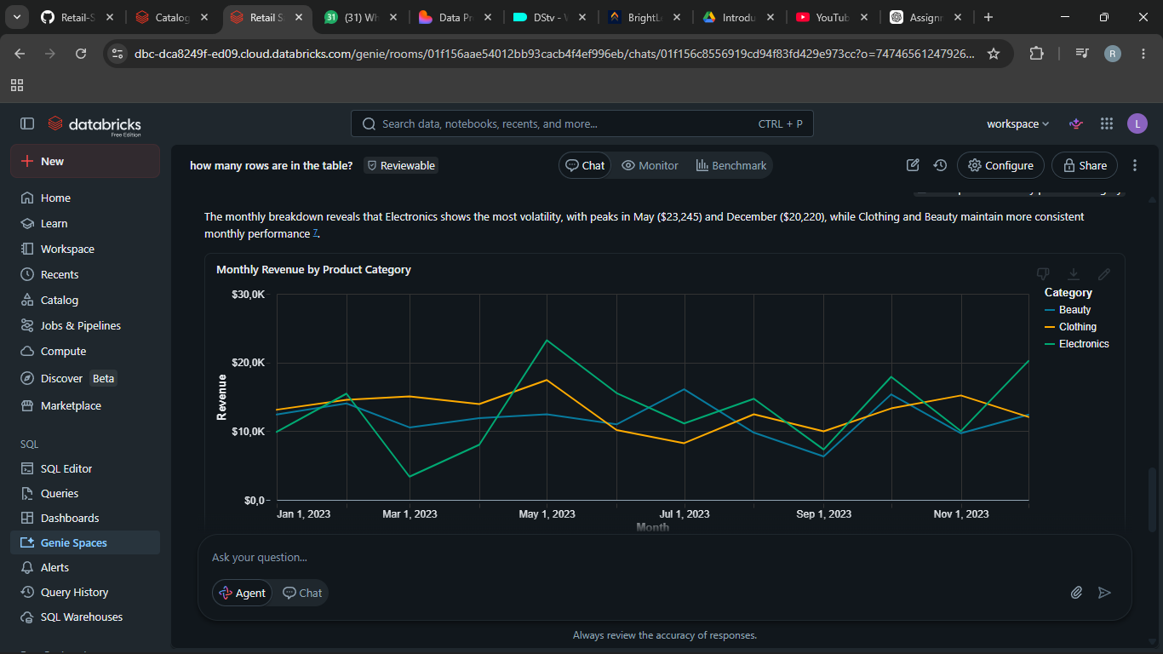
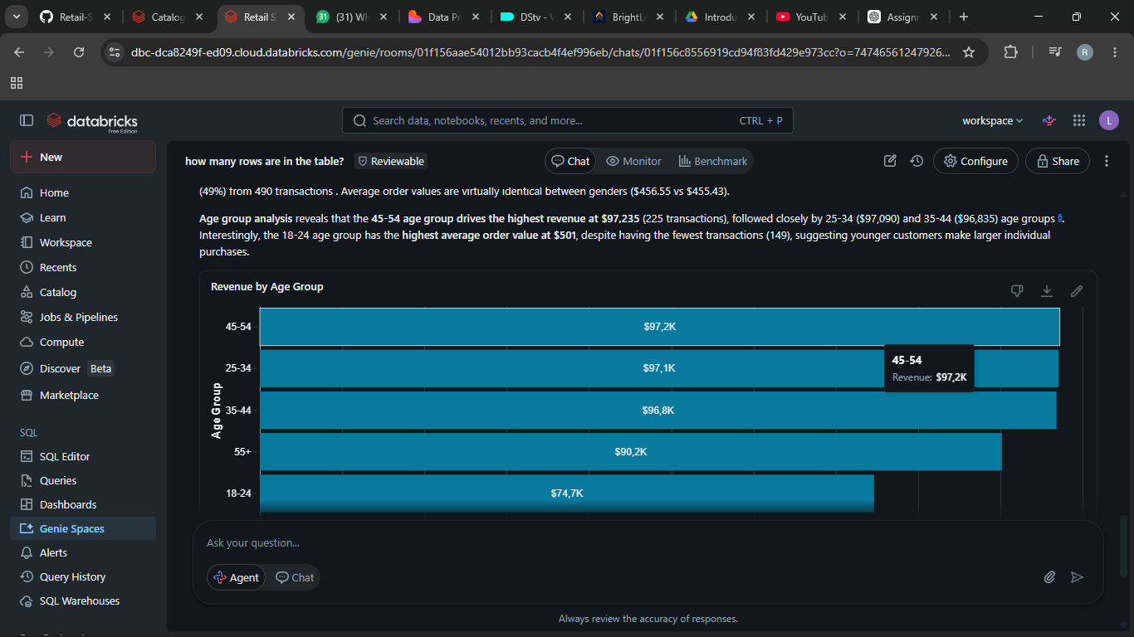

STEP 6: TEST WITH 10 QUESTIONS
- What is the total revenue generated?

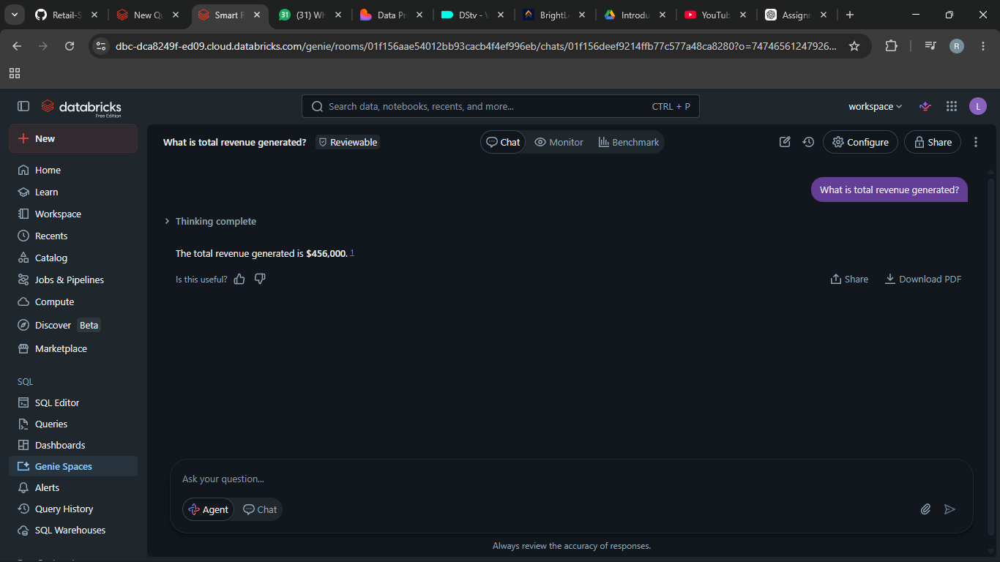

- Which product category generated the highest sales?
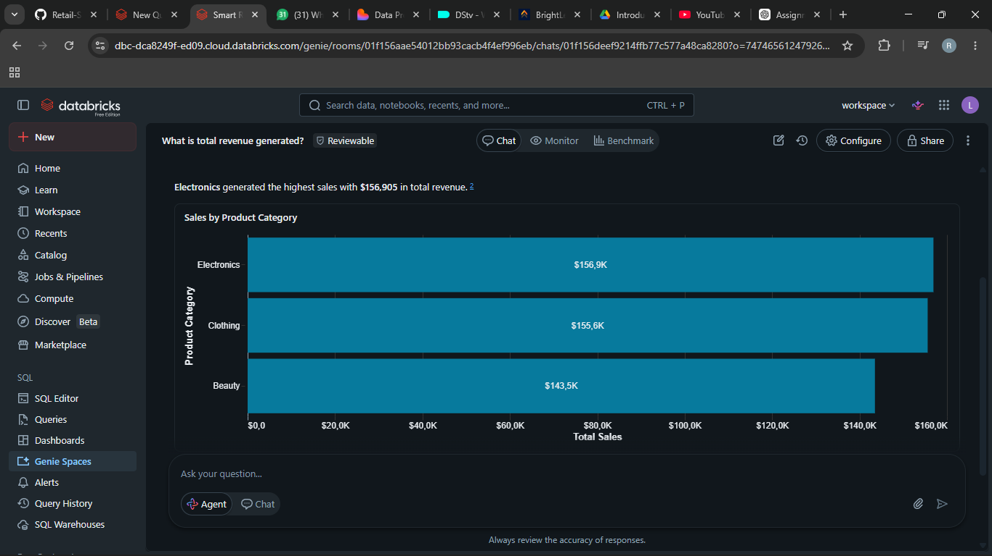

3. Which product category generated the lowest sales?
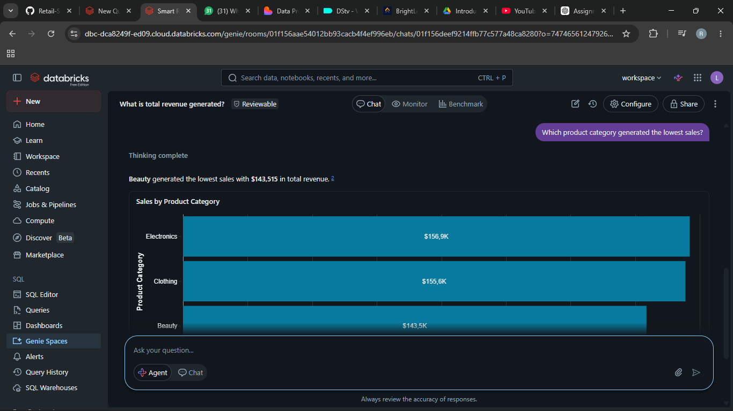

4.What is the average transactions value?
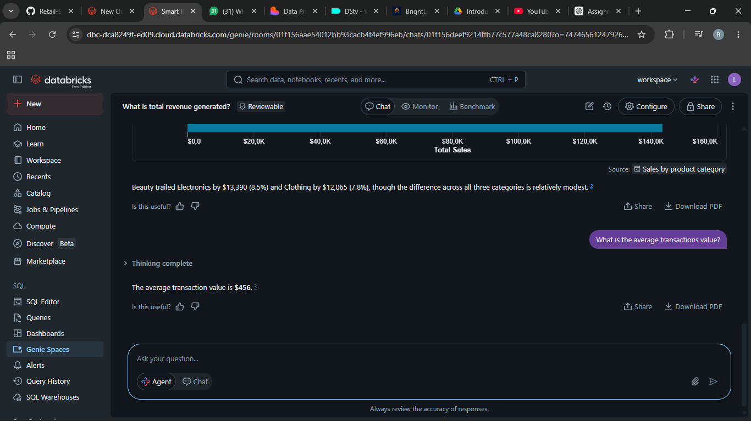

5. Which Gender spends the most money overall?
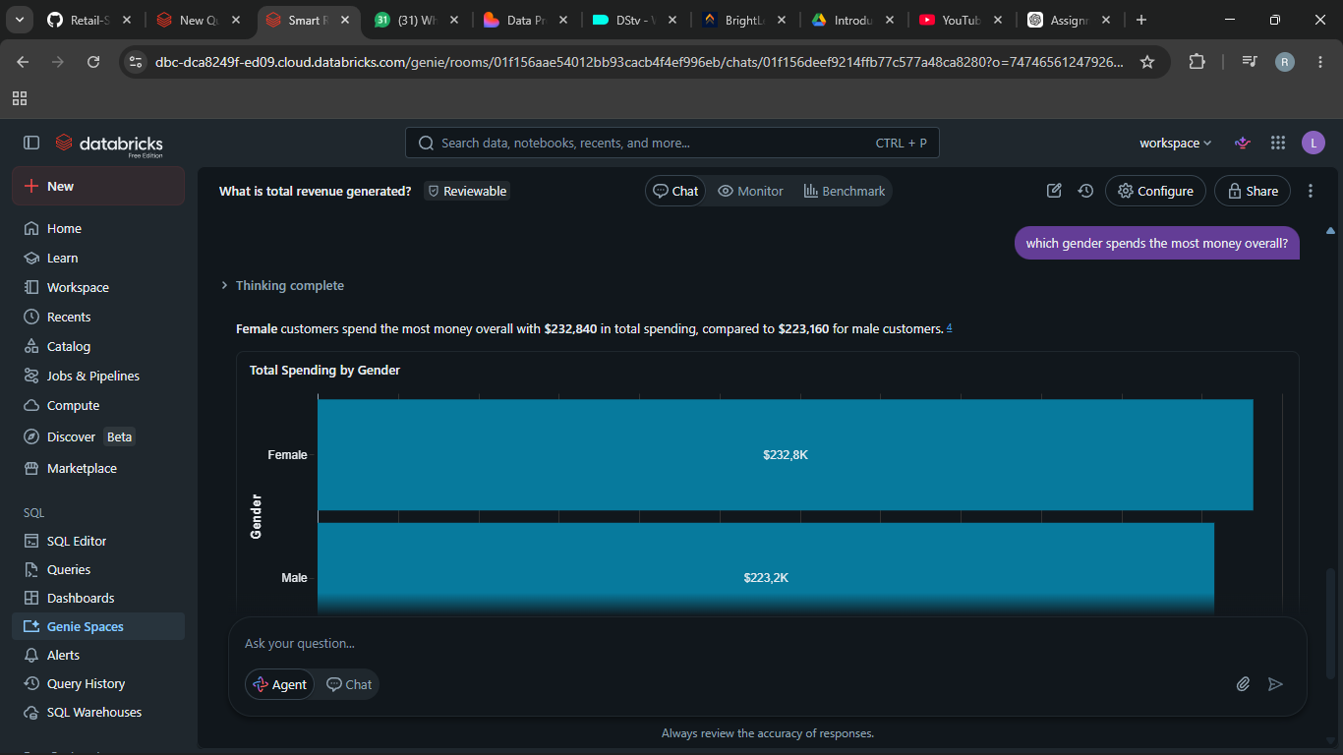

6. Which age group purchases the most products?
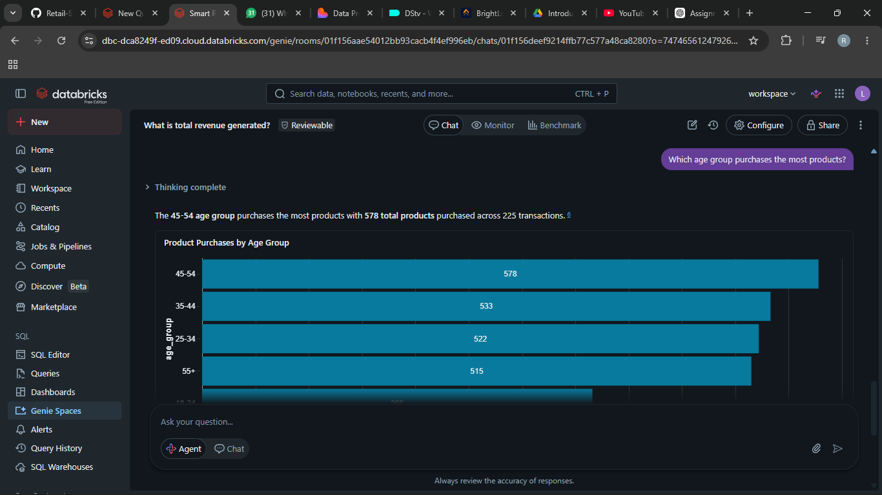
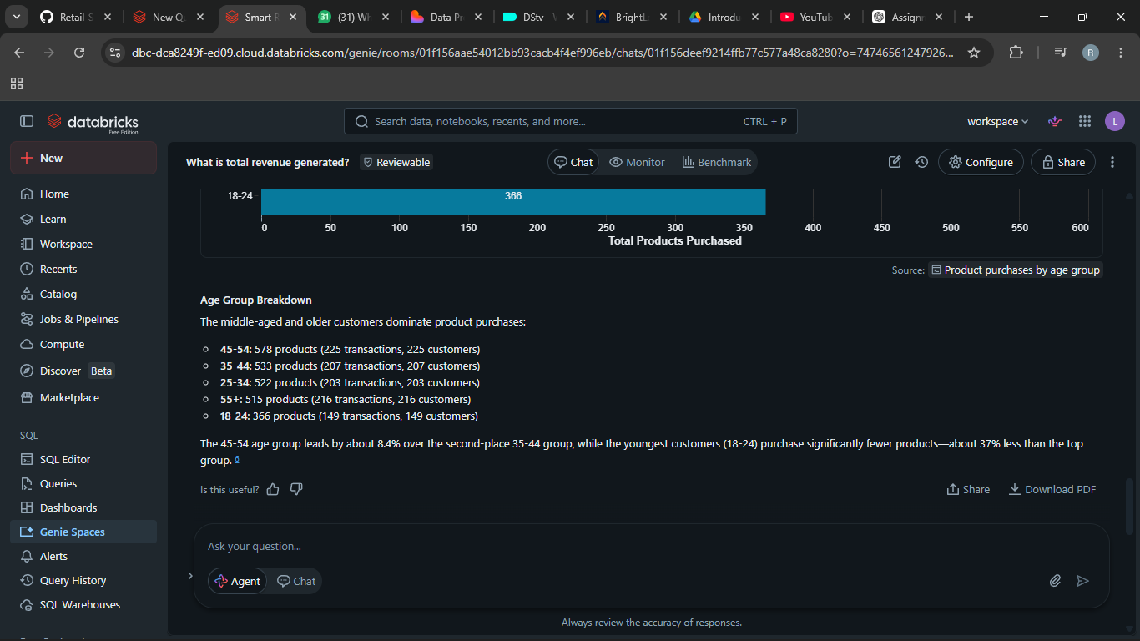

7. which month had the highest sale revenue?
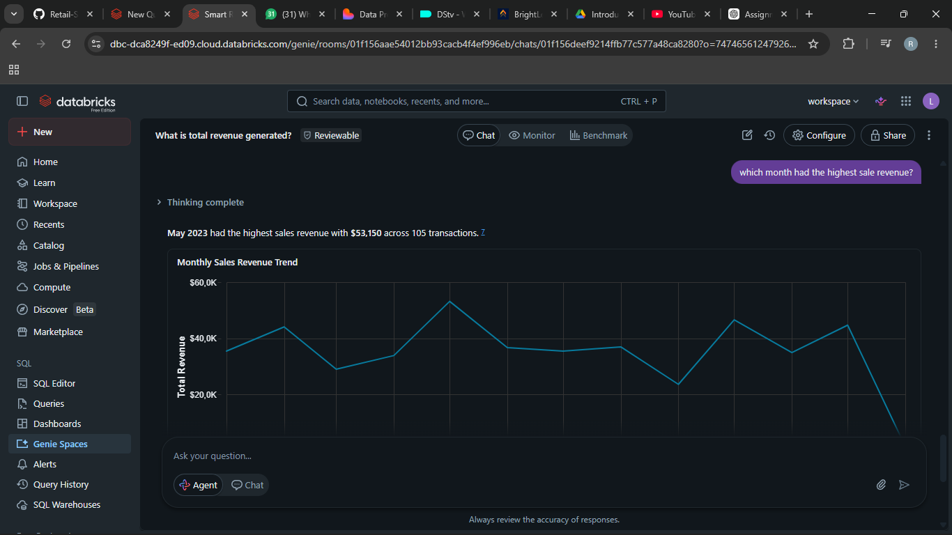

8. what are the top 3 best-selling product categories?
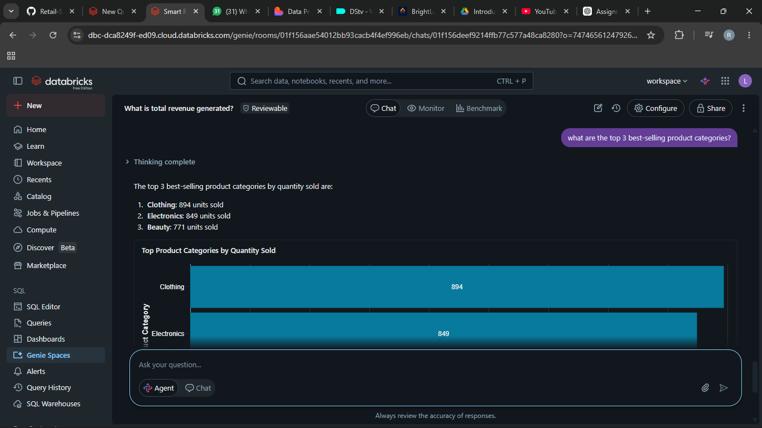

9. which product category is most popular amongst customers under 30?
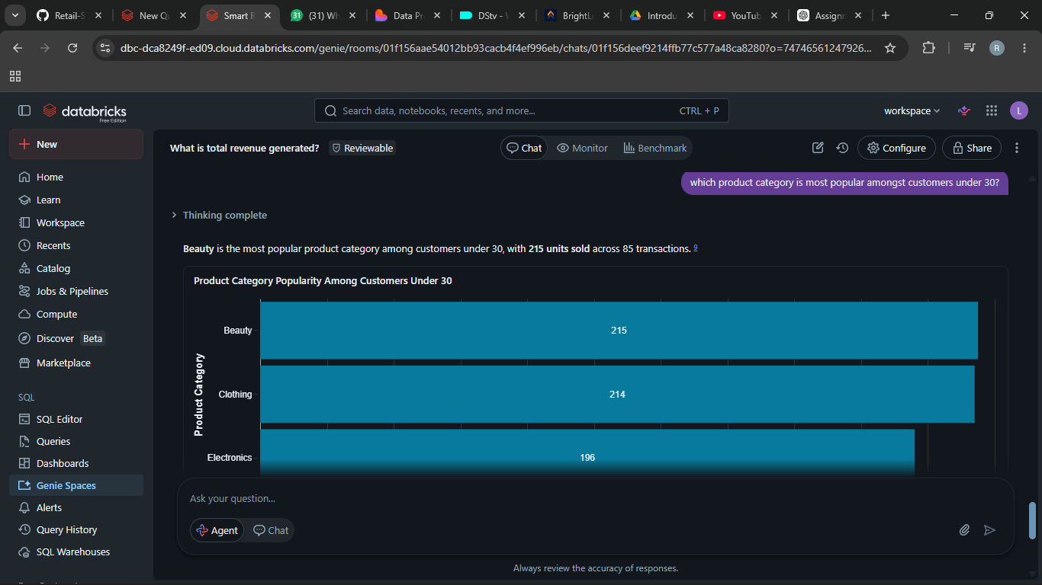
10. what recommendations can improve store revenue?
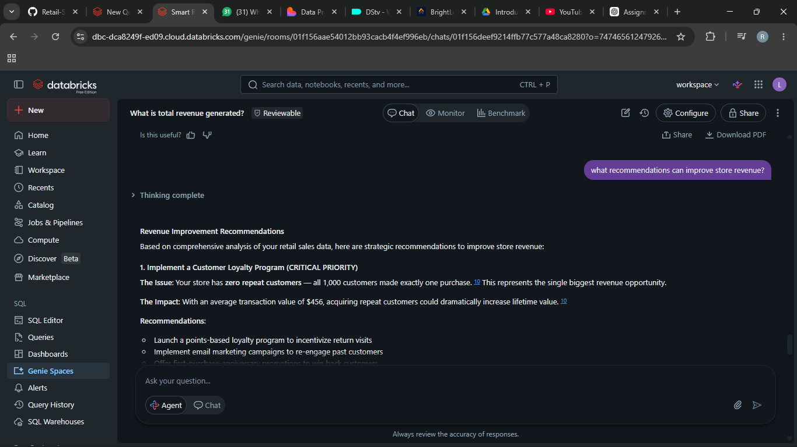

STEP 7: Validate the Answers
Question 1 : Which product category generated the highest sales?
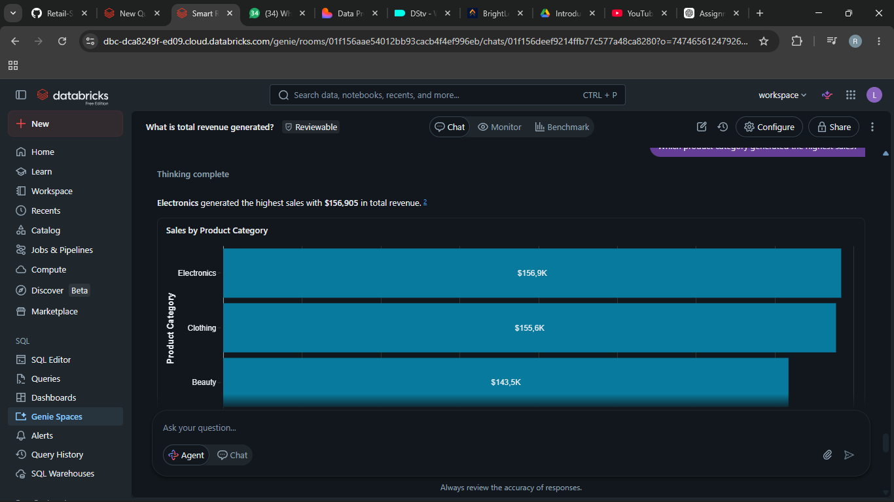

Validation SQL:-
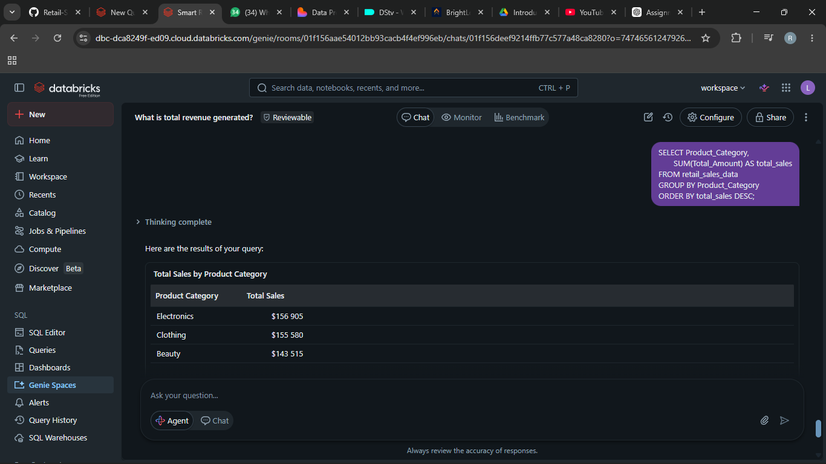

Validation Question 2: Which month had the highest sales revenue?
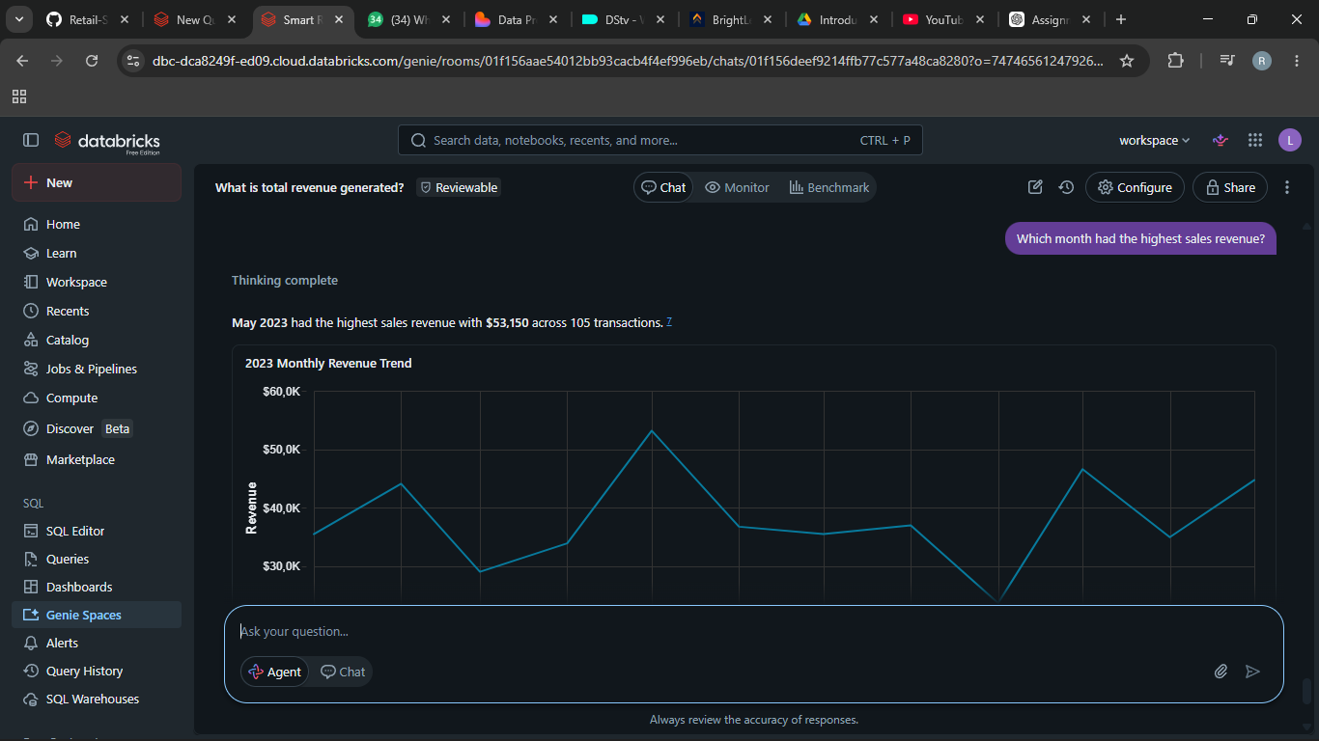
SQL Validation :-
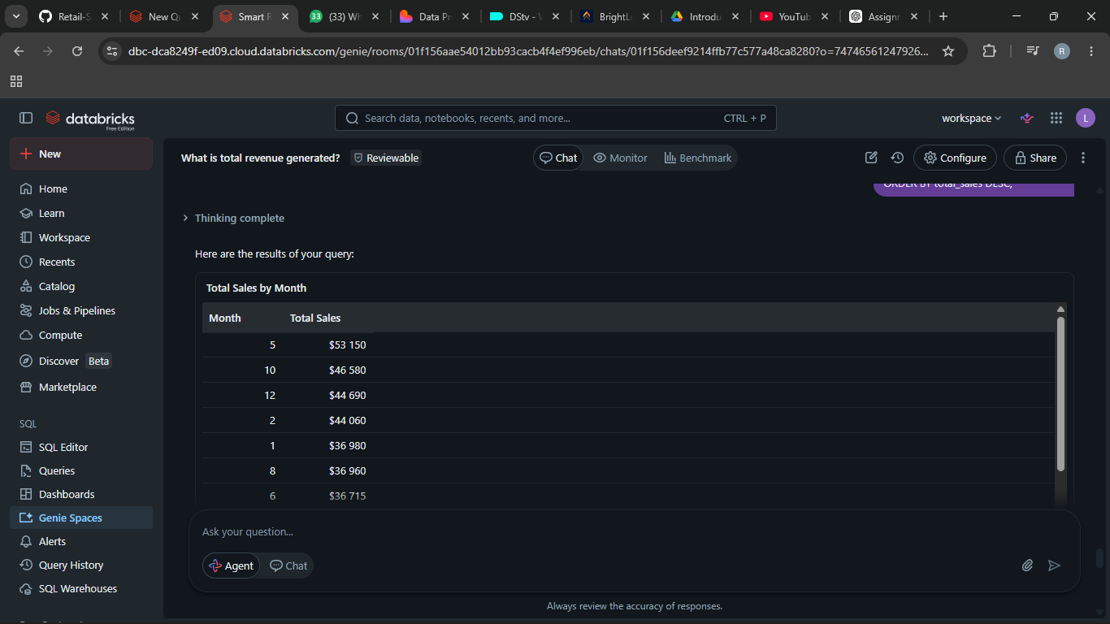
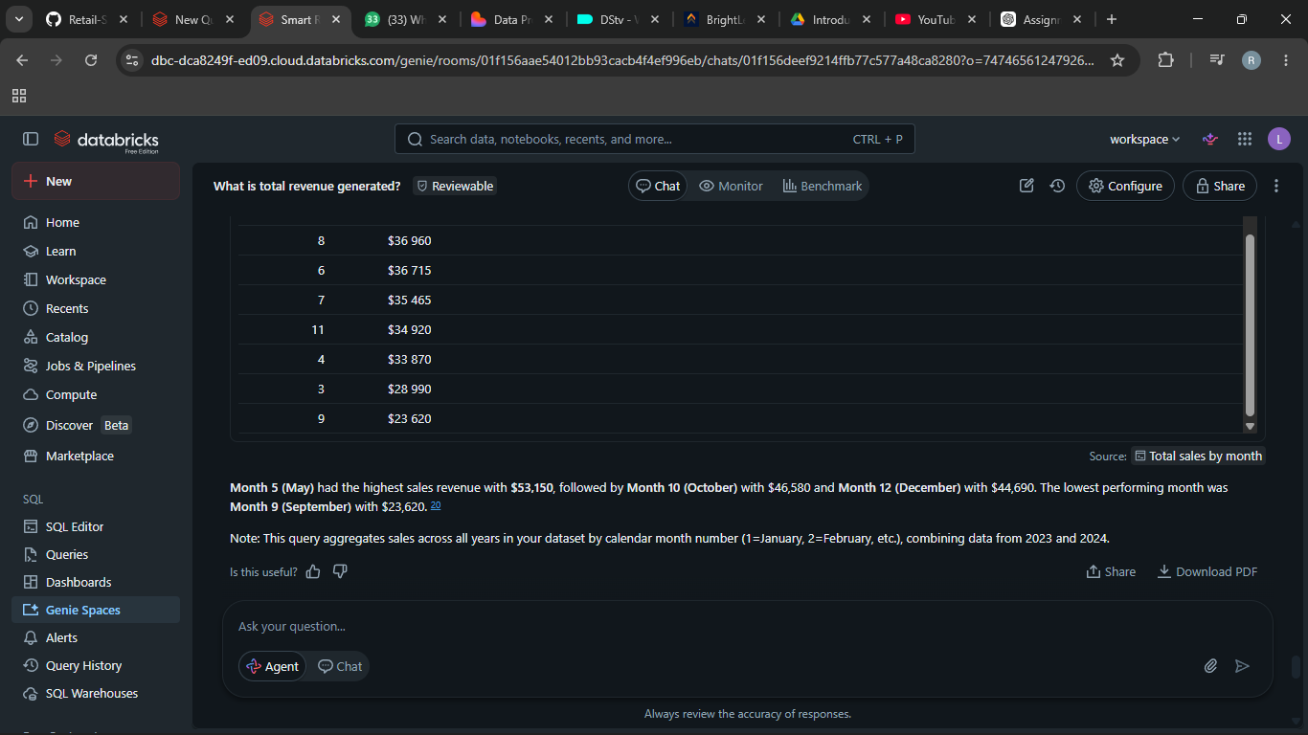

Validation Question 3: Which gender spends the most money overall?
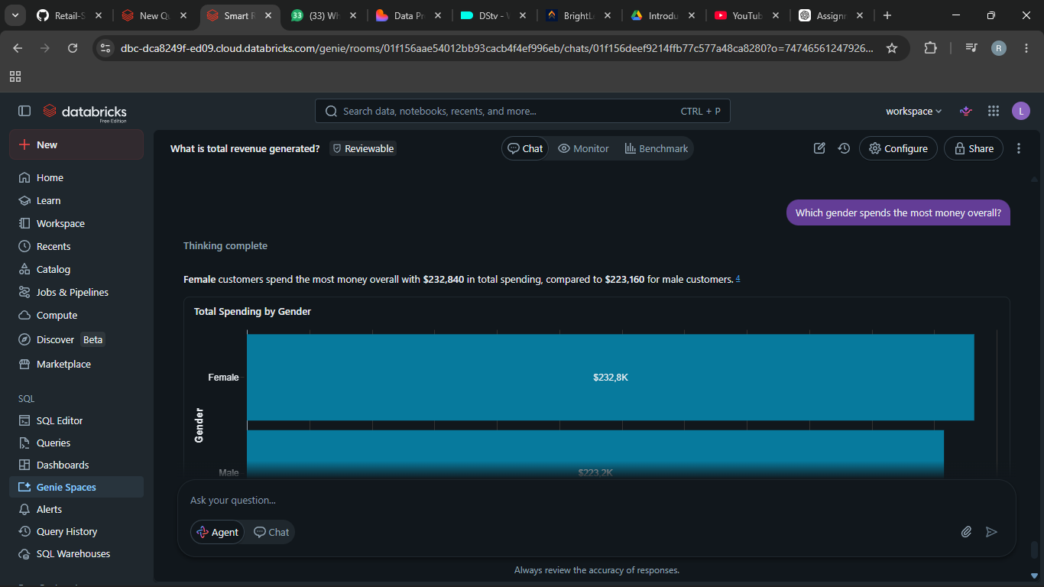

SQL Validation:-
SELECT Gender,
SUM(Total_Amount) AS total_spending
FROM retail_sales_data
GROUP BY Gender;

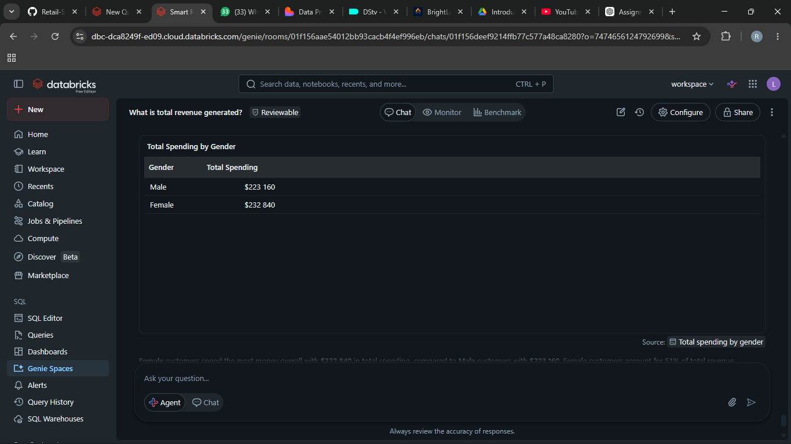
STEP 8: KEY INSIGHTS: -
11. Key Insights

The Smart Retail Performance Advisor revealed several important business insights:

* Electronics products generated the highest revenue
* Female customers spent slightly more than male customers
* Customers aged 18-24 were the strongest purchasing group
* May achieved the highest sales performance
* Beauty products performed below expectations

These insights can help management improve decision-making and marketing strategies.

12. Business Recommendations: -

Based on the analysis, the business should:
1. Increase investment in Electronics promotions
2. Improve marketing for underperforming categories
3. Introduce loyalty campaigns targeting ages 26–35
4. Prepare additional stock for high-sales periods like May
5. Use customer segmentation for personalized marketing

13. Conclusion

This project successfully demonstrated how a Retail Sales Data Agent can be built using Databricks and a retail dataset.
The Data Agent was able to answer business questions, identify sales trends, and provide useful business recommendations. The project also highlighted the importance of validating AI-generated answers using SQL queries and dataset summaries.
One challenge encountered was ensuring that the agent handled ambiguous questions correctly without making assumptions. In future improvements, additional datasets and more advanced business metrics could be included to improve analysis capabilities.
GitHub Repository Link : https://github.com/NonoSebk/Retail-Sales-Data-Agent-.git

